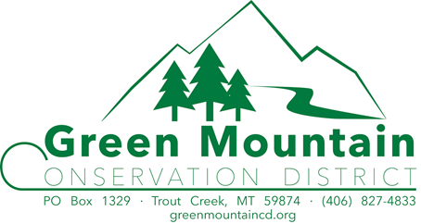

Meeting Minutes
August 21st, 2019

Supervisors Present |  | Employees Present
Kent Wilby |  | Leona Gollen
Terry Hightower
Mindy Ferrell via conference phone |  | Advisors Present
Sean Moran
Bill Neageli v |  | Ryan Kreiner FWP
 |  | Valerie Kurth DNRC
Associate Supervisors Present |  | Visitors Present
Jackie Nichols |  | Melinda & Adam Anakalea | Art Harlow
 |  | Mary

Meeting called to order at 7:05 p.m.

Meeting Agenda items not always taken in order that they appear

Introductions

Minutes 2019
- A motion to approve July 17th, 2019 meeting minutes as submitted was made by Sean 2nd by Bill, motion carried.

Financial Report
- Leona reviewed the financial report with the board for the last period.
- A motion to approve the financial report for last period was made by Bill, 2nd by Sean, motion carried.

Administrator’s Report:
- Valarie Kurth – New Water Planner for the Clark Fork and Kootenai
- Jean Dunn Resignation
  - A motion to accept Jean Dunn’s resignation was made by a reluctantly Kent, 2nd by a reluctantly Sean, motion carried reluctantly.
  - She will be sorely missed.
- September 25th Area V meeting Bitterroot Corvallis
  - Bill, Mindy, Leona, Possibly Sean.
  - A motion to pay for motel rooms was made by Bil, 2nd by Sean, motion carried
- Jason Garber - DNRC new stream permitting Coordinator
- Blackfoot Bill
  - Leona contact Blackfoot Coop to see if our phone and internet bill could in any way be reduced. Signing a two-year contract would save us $1.00 per month. A five-year contract would save us $15.75 per month.
  - A motion to leave it as is was made by Bill, 2nd by Sean, motion carried
- MACD Convention Nov. 19-22 Kalispell
  - Bill, Mindy, Leona
  - Leona will make 3 room reservations. Make Bills starting the 18th
- Final Inspection Dates
- Sept. 11th West side of County, Sept.13th East side of County.
- Auto fill Energy Partners
  - A motion to pay the Energy Partners pre-paid auto fill in the amount of 633.25 was made by Sean, 2nd by Bill, motion carried.
- Sign is done for Eastern Sanders side of county and will be installed Monday.
- Financial report review time
  - Table this until next month meeting.

GMCD Website: (greenmountaincd.org)
  - See attached

LCFWG COORDINATOR “WATERSHED REPORT”
  - See attached

MT FWP Report
- Sampling on vermillion River. One of the electrodes was smoking
- FWP had an open house at the office last night.
- Proposing to open the upper Thompson to anglers.
- Changing bass regs in Kalispell and flathead from 5 bass fish any species to 1 large mouth and 15 small mouth. It is staying the same here.

NRCS Report:
- Travis will continue to assist the Deer Lodge NRCS Field Office until the new District Conservationist reports to duty there. The new District Conservationist will likely report to duty around the beginning of the fiscal year – Oct 1). Travis will continue to work in the Plains FO 1-2 days/week, but my schedule is variable. Travis can be reached via email or phone in Deer Lodge @ 415-4040 anytime.
- Troy continues to work full-time in Sanders County and is available to assist as well.
- Staff members from the Ronan NRCS FO (676-2841) are available to assist Sanders County as needed.
- NRCS staff members from both Plains and Ronan are in the process of completing the Long-Range Plan (LRP) for Sanders County. Samantha Tappenbeck is assisting with the LRP for Sanders County as well. The estimated completion date for the LRP is mid-September.
- Troy continues to conduct resource inventory work and conservation planning for the 2020 Sanders County Targeted Implementation Plan (TIP). The main intent of the TIP will be to assist landowners with the implementation of forest health related conservation practices on properties located north of the Vermilion River. In 2020, the TIP will focus primarily on properties along the Bull River, Elk Creek, and EF Blue Creek. In addition, both Travis and Troy continue to work (contract dev/admin/support) on contracted EQIP, CSP, and WRP projects throughout Sanders County.

(SWCDM) Soil & Water Conservation District of Montana
- No Report
- SWCDM has hired a Coordinator so at the moment until MACD figures out what their future holds, the MACD director hiring process has been postponed.

Education
- WF meeting sept 12th at 10:00
- In September Mindy will be visiting the schools to go over the Water Festival arrangements
- Mindy will try and set up meeting concerning Envirothon with Noxon.

Old Business:
- Reminder of Cadastral mapping.
  - This map is very handy for GMCD.
  - Sean will meet with Leona to review how to use the mapping system.

Building Repair Project:
- Nothing to Report

No-Till Drill/Gopher-Getter:
- Nothing to report

New Business:
  - Sean gave a WRTAC meeting update.
  - NWE Boat Tour update
      - Kent, Terry and Ryan. The trip was very informative and NWE is becoming more interested in what is happening on their shoreline. They have requested to review our 310’s and would like to have more input on what is happening on or near their land. There is a section on the cherry creek side of the Res., that is having major erosion problems and NWE wants to stabilize it with a soft approach. They will be submitting a 310 application for this project and want to discuss at length with GMCD.
    - They showed the soft approach as woody material that they want to use, willow, dogwood etc. This will all be outlined in their 310 application
    - On the Boat tour there was a lot of discussion and questions as to whether GMCD would allow certain establish project from the past, now.
    - GMCD is very excited about working closely with NEW hoping to establish the same relationship and repour that we have with Avista.
    - NWE is hoping that their project may be establish as an example project for the rest of Thompson Falls Res. Maybe we can come up with a base line model.

  - Employee Direct Supervision
    - Table until September meeting

Subdivision Review:
- Nothing to Report

Time Allowed for comments from the Public not already on the agenda:
- Mindy requested the the Associate Supervisors/Technical Adviser list be reviewed.

310 Activities

SW-11C-19 FWP
- Keep this on agenda until October to complete the investigation.

SW-01-19 Hause
- A motion to contact the engineer that works with DNRC and schedule an appointment was made by Kent, 2nd Bill motion carried.

SW-25-17 Finch Dock Inspection - Sept 3rd - Terry
- This is still a go and Terry will attend.
- FWP waives site visit.

SW-23-18 Baxter Extension
- A motion to extend Baxter’s permit # SW-23-18 until August 31st 2020 was made by Bill, 2nd by Kent, motion carried.

SW-19C-19 Sutherland Complaint
- Kent will contact the owner and schedule a site visit.
- Bill will try and get the 3rd previous owner’s name to see if they had a 310 permit.

SW-20-19 Harlow Bridge
- A site visit was scheduled for August 22nd, and Ryan & Kent will attend.
- Motion to approve the application as complete and approval with modification established at the the site visit was made by Bill, 2nd by Sean, motion carried.

SW-27-18 Avista Bull River Work Completion Form
- A motion that this project is complete and the permit is closed was made by Bill , 2nd by Kent, motion carried.
- 1 member Abstained

SW-09-19 Avista North Shore Work Completion Form
- A motion that this project is complete and the permit is closed was made by Bill , 2nd by Kent, motion carried.
- 1 member Abstained

SW-13-19 Albert work Completion Form
- A motion that this project is complete and the permit is closed was made by Bill , 2nd by Kent, motion carried.

A motion to adjourn at 9:00 pm was made by Bill, 2nd by Sean, Motion carried.

Respectfully Submitted. Approved.

Leona Gollen Kent Wilby
Administrator Chairman

Report to the Green Mountain Conservation District
August 21, 2019
Brita Olson, Lower Clark Fork Watershed Group (LCFWG) Coordinator

Website
- Final June meeting minutes were posted.
- DRAFT July meeting minutes were
- August agenda was posted
- Last month’s stats:

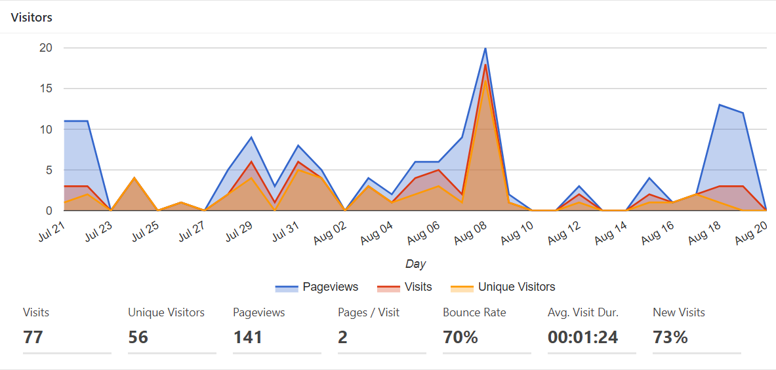

Meetings
Lower Clark Fork Watershed Group 3rd Quarter Meeting is scheduled for September 4, and will take place at the GMCD office.

Project Updates
Sims Meander Project:
- We were not invited to submit a Bring Back the Natives (program of the USFWS) full proposal. I am working with the Clark Fork Grant Writer(s) to develop a revised funding plan, pending the details of the final design that Craig Neesvig (USFS) puts together. I will do my best to keep the board apprised of the details on any plan that we develop and will, of course, be working closely with Leona on this as well.
- Leona and I met with Hannah Riedl, our project contact with DEQ, on August 20 to review the details of our draft contract for 319 funds, which will be one of the largest funding sources for this project.
- Craig plans to share the nearly final design of the project at the upcoming meeting on September 4 for partner review.
Crow Creek Restoration Project – Phase 2: Construction is completed, with the only remaining work being willow installation in October. See photo of a portion of the newly revitalized channel.
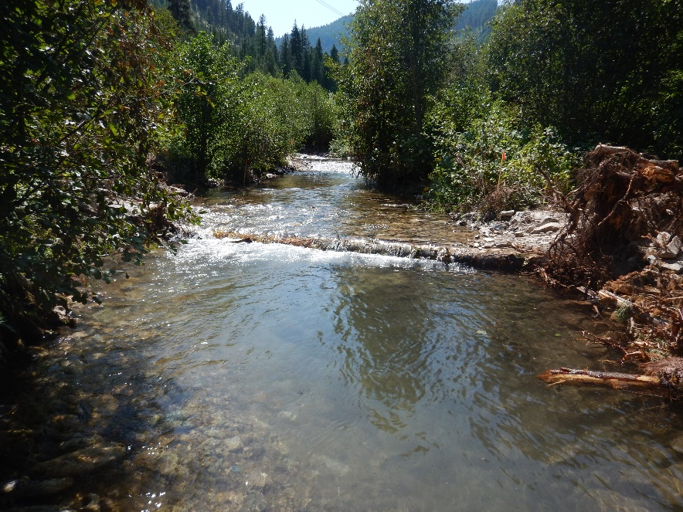
Graves Creek Pilot Habitat Enhancement Project: Four structures (one pictured below is an example) were built on Graves Creek in August. These will be monitored to evaluate their ability to sort spawning-size gravel and increase instream habitat complexity.
