

Meeting Minutes
January 20th, 2021

Supervisors Present | Employees Present
Bill Naegeli | Leona Gollen
Terry Hightower | Advisors Present
Mindy Ferrell (Zoom) | Jason Blakney FWP (Zoom)
Sean Moran (Zoom) | Brita Olson LCFWG (Zoom)
 | Arthur Potts Avista Utility (Zoom)
Associate Supervisors Present | Andrew Welch (North Western Energy) (Zoom)
 | Visitors Present
 | Gene Jopling (Zoom)
 | Bud Scully (Zoom)
 | Michael Beckman
 | Ronald & Michelle Knuth

Meeting called to order at 6:00p.m.
- Due to the high level of safety concerns for large gatherings, GMCD has limited the number of attendants at our GMCD office for the meeting. All other interested parties will use the Zoom Meeting Room.

Meeting Agenda items not always taken in order that they appear

Introductions
- Bud Scully: New Superintendent for Thompson Falls Schools.
Minutes 2020
- A motion to approve December 16th, 2020 meeting minutes as submitted was made Mindy by, 2nd by Sean, motion carried.
Financial Report
- The financial report was sent to all Supervisor prior to the meeting.
- A motion to approve the financial report for last period was made by Sean, 2nd by Terry motion `carried.
- A motion to approve all invoices for January 2021 was made by Mindy, 2nd by Terry, motion carried.

Administrator’s Report:
Election of Officers
- A motion to keep the same slate for Chairman and Vice Chairman as 2020 was made by Mindy, 2nd by Sean, motion carried.
- A motion to appoint Edward Bud Scully to the open Supervisors position was made by Mindy, 2nd by Terry, motion carried.
Approval to sponsor Simms Meander Avista Grant
- A motion to sponsor the Avista Simms Meander grant was made by Mindy, 2nd by Terry, motion carried.
- One Supervisor Abstained
Annual plan of operations
- Remove choosing 310’s for consideration and adding good example 310’s to the website.
- A motion to accept the annual plan with the listed modifications was made by Sean, 2nd by Terry, motion carried.
Phone List Update is still in progress. It will be completed by next month’s meeting
New 2021 mileage rate is .56 cents per mile.
We had thirty-eight 310 application in 2020
LCFWG supplemental agreement for pollinator grant
- A motion to accept the LCFWG supplemental agreement for the pollinator grant was made by Mindy, 2nd by Terry, motion carried.
LCFWG modification 1 for supplemental empowerment grant
- A motion to accept modification #1 to the LCFWG supplemental agreement for the empowerment grant was made by Terry, 2nd by Mindy, motion carried.
310 arbitration and judiciary process.
- We reviewed the arbitration and judiciary timeline for the 310 process.
- The 310 applicant has 30 days after receiving notification letter from GMCD to either submit the arbitration form to the GMCD office and/or 30 days to submit the judiciary dispute to the county court if they do not agree with the Board decision.
Reminder concerning email discussions between board members
- We reviewed the state law concerning communication between Supervisors about any official board business.
Website Report and update review
- A number of updates have been made.
- A motion to go live with the website was made by Mindy, 2nd by Bill, motion carried.
- Can we connect with other entities? (Brita & Leona will look into this.)
- Can a hyperlink be put on the Sanders County calendar?
Lower Clark Fork Watershed Group (LCFWG) Report
- See attached report
Fish Wildlife and Parks (FWP) Update
- A new director has been nominated. Hank Worsech. Everyone seems to be pleased.
Natural Resource Conservation Service (NRCS) Update
- See Attached
Avista Utilities Update
- At this time, we’re primarily working on Annual Reporting and project planning for 2021, and preparing for WRTAC and TRTAC meetings on 1/19 and 1/20, respectively. We’re currently still working to finalize the details on the call-in method, and plan to have the call-in/log-in details out to members Tuesday. The calls are scheduled to begin at 1:00pm MST.
- The current wind storm has created a lot of work on the Terrestrial side of things. Arthur is beginning to receive calls and emails from folks that are working on clearing trees off of structures and cleaning up downed trees. He is trying to spread the word that folks will need to obtain Emergency 310s for trees along the shoreline, but anticipate that there will be numerous trees removed before folks are aware of this requirement. Avista has experienced very substantial tree loss throughout the CFSA Project Area. In addition, our Natural Resources office is still without electricity, which has also impacted our phones. In the meantime, Arthur is encouraging anyone who needs assistance to call his cell (254-913-0997), and be patient, as he expects this process to take several weeks/months. He is currently advising folks that all rootwads will need to be left in place, and placed back into holes if possible.
Public Education
- Nothing to report
Supervisor Education
- Nothing to report
New Business
NWE update
- Relicense Comments end March 11th then a revised plan will be completed.
- Leave this on agenda for comments from Board.
Building Repair
- Terry will remove the fence that is blown down.
Time Allowed for comments from the Public not already on the agenda:
- We have had a lot of calls about trees being blown over

310 Activities
SW-08-20 Yellowstone Pipeline
- We received a email letting us know that this project will not proceed until 2022 if then so we will be closing the project and they will have to re-submit when applicable.
- A motion to close this application was made by Terry, 2nd by Mindy, motion carried.
SW-36- Meadows
- A motion to deny the application for the below listed reasons was made Sean, 2nd by Terry, motion carried
- Amount of material to be removed not listed
- Total linear distance to be “cleared” not clear
- No Pictures to visually see project; either typical alders or bridge timbers
- Bridge timber removal not mentioned.
- Need further quantification of project
- When you have fine material, you have the potential of banks falling in, wood in creek can dissipate energy and/or protect banks.
- FWP is concerned with this project and removing alders from low radiant stream is not the answer – woody debris provides cover for fish. This will be hard to approve from a FWP perspective. This area of the stream is sediment rich already, warms in the summer and is marginal trout habitat.
- A site visit is scheduled for more information Sean, Jason, Bill, Tabled until March.
SW-37-20 Beckman
- A motion to accept as a completed application was made Mindy, 2nd by Terry, motion carried
- Stone dust will be used on the trail
- Roots will not be pulled from the one down tree on the bank.
- FWP would like to do a site visit.
- Site visit is scheduled for Friday 22nd 10:00 am, with Jason, Bill present.
SW-38-30 Knuth
- A motion to accept as a completed application was made Mindy, 2nd by Terry, motion carried
- This was an existing dock permit that Mr. Rummel submitted but never constructed.
- The platform is 1-2 ft above high water
- The dock will be removed by dragging it in the water to the boat ramp.
- There is no plan to remove any alders except a dead tree that is laying on the bank.
- Site visit will be schedule with Jason, Arthur, Terry, Mindy on Monday 25th at 12:30. Take flagging.
SW-01-21 Rahn
- A motion to accept as a completed application was made Bill, 2nd by Sean, motion carried.
- A motion to accept the project as submitted was made by Sean 2nd by Terry, motion carried.
- Until the trail issue is finalized Gene will have to use the existing trail only.

A motion to adjourn at 8:15 pm was made by Mindy, 2nd by Sean, Motion carried.

Respectfully Submitted. Approved.

Leona Gollen Bill Naegeli
Administrator Chairman

Natural Resources Conservation Service
Plains Field Office
7487 MT Hwy 200, Plains, MT. 59859
406.826.3701.

Green Mountain Conservation District Meeting
NRCS Report
January 19, 2021

The Plains Service Center is in “Phase I” which means visitors are allowed to meet with staff with pre-scheduled appointments and social distancing and masks are required, however, visitors are not allowed in the building. Meetings must take place in the parking lot or in the field.

We are currently working on multiple applications for white pine restoration in the Green Mtn CD service area through our Targeted Implementation Plan (TIP).

We are also working on developing a new TIP for stream restoration work in the Green Mtn CD service area in conjunction with the Lower Clark Fork Watershed Group. Our proposal is currently in the review process.

We are also working on 2021 CSP applications.

February will be a busy month for us due to several deadlines related to processing CSP and EQIP applications.

Thank you,
Dillon

Dillon Martini
District Conservationist
Plains Field Office


Report to the Green Mountain Conservation District
January 20, 2021
Brita Olson, Lower Clark Fork Watershed Group (LCFWG) Coordinator
Website
- Final November Meeting Minutes were posted.
- Draft December Meeting Minutes were posted.
- January agenda was posted.
- Website users over November: 45
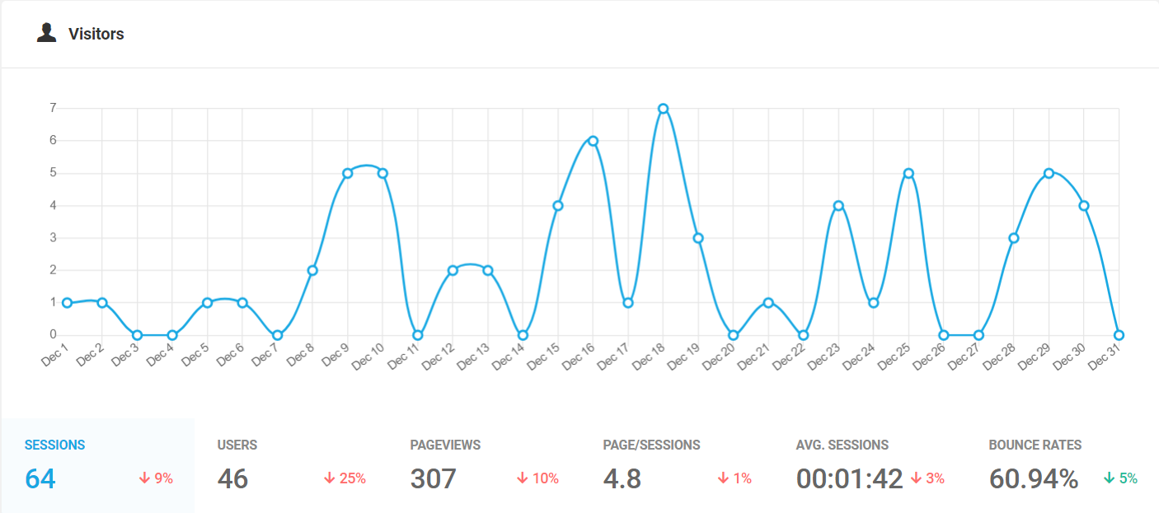

Project Updates
Empowering watershed stewardship and restoration on private lands (223 grant) / Bull River Revegetation
- Continued working on a draft “Roots for Rivers” TIP with Troy Hidy, which should lay the ground work for continuing revegetation efforts with landowners into the future. To start, we’ve decided that this will likely focus on the Bull River, as we have to most momentum in that drainage to capitalize on.
- Completed a revised draft GMCD website for review and met with Leona to discuss.
Pollinator Program
- ESCCD, GMCD and LCFWG met in January to finalize some planning details so we are ready to “break ground” in the spring.
- Completed a native plant order with Great Bear Native Plants out of Hamilton, which will be ready for pick-up in May.
- Started planning to purchase / source materials for the project and will be putting together orders in the next month or so.
Sims Meander Project:
- No activity this month; but the USFS plans to commence NEPA activities in January and the CFSA App B Project Plan will be reviewed at Avista’s Water Resources Technical Advisory Committee in late January as well.

