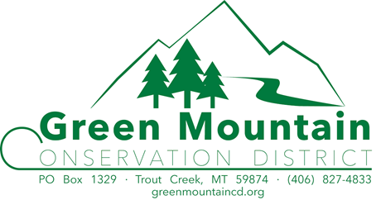

Meeting Minutes
May 15th, 2019

Supervisors Present |  | Employees Present
Kent Wilby |  | Leona Gollen
Terry Hightower
Mindy Ferrell |  | Advisors Present
Sean Moran |  | Travis Lemke
Bill Naegeli |  | Ryan Kreiner
 |  | Samantha Tappenbeck
Associate Supervisors Present |  | Visitors Present
Jean Dunn |  | Mary Hendrix (CARDD) | Gene Jopling
 |  | Bill Fister

Meeting called to order at 6:55 p.m.

Meeting Agenda items not always taken in order that they appear

Introductions

Minutes 2019
- A motion to approve April 17th, 2019 meeting minutes as submitted was made by Mindy 2nd by Sean, motion carried.

Financial Report
- Leona reviewed the financial report with the board for the last period.
- A motion to approve the financial report for last period was made by Bill, 2nd by Terry, motion carried.

Administrator’s Report:
  - Meet with ESCD once per year
  - A dinner meeting once a year was decided on and it will be in the first quarter of the year.
  - GMCD agreed that that to cover our bases we should post this meeting
  - Road Sign on ESCD side of County
    - We will have the printery make the new sign.
    - The attached template was reviewed and everyone approved.
- The 223 grant has been submitted for the sign on the Lincoln Co. boarder
    - Liability Insurance coverage for others use of Building
      - A renter or occupant would need a general liability policy (just like we have) and contents coverage for their own property. Cost would be determined on coverage.
      - A motion to rent out the building would be on a case by case basis was made by Bill, 2nd Kent motion carried.
      - 2 Supervisors obtained and when asked why, Mindy said that she felt the bldg. was built and is maintained with public funds. The design indicates that public space is available. We are a public entity and in reality, few local groups carry their own insurance coverage. As an additional comment, the schools, the Noxon Ambulance bldg., and other publicly owned building do not have similar policies
      - It was also brought out by DNRC that this building is used for an office and not all public buildings are open for use and it would stand to reason that this building is not due to the fact that it is an office.

      - CD Investment
        - First Security Bank CD options
          - $500.00 minimum deposit
          - There are 6 term options 3 months = 0.03%, 6 months = 0.07%, 12 months = 0.20%, 24 months = 0.40%, 36 months = 0.55%, 60 months = 0.95%.
          - At the end of each term you would and the option to roll it over or take it out.
          - The penalty for early withdrawal depends on how late in the term you withdrawal the funds. i.e. if you have a 12-month term CD and you withdrew the funds at 11 months you would get a certain percentage of the interest but not all of it.
          - Whitefish Credit Union;
          - WFCU does not offer CD investments
          - We are now getting 1.6% on our savings account far more than even the longest CD option.
          - Interest in paid out every 6 months in June & December
          - It is re-evaluated every 6 months and was just raised from 1.3% to 1.6%
        - Leona will contact convention planner for ideas on a financial workshops at the State CD convention..
- NWE relicensing meeting is October 15th from 6:00 pm – 7:30 pm at TF Community Center.
  - Kent will attend this meeting
- Mary Hendrix from DNRC introduced herself as the new Conservation District Specialist. She is replacing Dave Martin who retired.
  - Her job is 50% outreach and 50% web work.
  - She was at the Gallatin CD as the administrator for 2 years.

GMCD Website: (greenmountaincd.org)
  - See attached

LCFWG COORDINATOR “WATERSHED REPORT”
  - See attached

MT FWP Report
  - Finished up walleye shocking 715 fish 25 were female most were 4-year-old males.
  - Fish ladders are open and fish are moving through
  - FWP is doing fish days and other education projects with the schools.

NRCS Report:
General
    - Lake County CD in partnership w/ ESCD was recently approved for a grant that will cover seed purchase and soil testing for producers interested in planting cover crops to improve soil health. Funding. The grant will cover up to 20 acres/landowner and $20/acre for seed purchase. To-date 4 Sanders County residents/landowners haven chosen to participate.
    - Travis would like GMCD to possibly do this next year.
    - There is a pollinator program that ESCD is doing and GMCD could be involved with this as well.
Programs
    - Funding for the 3 EQIP SI applications (high tunnel) has been obligated. Preapprovals for EQIP 2019-2 applications that have previously been ranked are scheduled for the first week in June. Western Sanders County (Green Mountain District) has two applications for the EQIP 2019-2 sign-up period. Troy is continuing to conduct inventory and evaluation of property’s along the Bull River in anticipation/preparation for the 2020 Targeted Implementation Plan proposal for Sanders County. Travis & Troy are going to reach out to landowners and show what NRCS is working on in the Bull River area and is working with Brita on a workshop with landowners.
    - Travis is looking into having a high tunnel (green house) work shop in October 2019
Outreach
    - Travis along with ESCD District Administrator Elena Marrinan conducted the annual poster competition in Eastern Sanders County on 4/24/2019. Presentations were given to 3rd, 4th, 5th graders in Plains on the topic We All Need Trees. Hot Springs and Dixon chose not to participate this year.
    - Travis is involved with adopt a cow project with Doug Padden.

(SWCDM) Soil & Water Conservation District of Montana
- See attached

Education
There are a lot of
spring outdoor education projects going on in which many of our partners as well as GMCD are participating.’

Mindy has confirmed Clark Fork Coalition to teach. Lilly will be doing the aquatic invasive at the Water Festival.

Stephanie Gillan who is the Tribal Natural Resources Department's new information and education program manager has confirmed that they will do a station at our WF this year.
- We do not have the rolling river trailer this year unless we have a person that can teach it and also pick up the trailer and return it to Kalispell.
- Ryan from FWP for the Fisheries station, Travis from NRCS for the Forestry station and, Ray Vinkey from the FS for the Tracks station have all been contacted and are willing to participate in the Water Festival this year.
- Char Milling is doing the riparian station again this year
- No application so far for the Natural resource youth camp.
- WF planning meeting May 30th starting at 9:30 am

Old Business:
- Nothing to Report

Building Repair Project:
- Nothing to Report

No-Till Drill/Gopher-Getter:
- Leona will inform ESCD that it was discussed and decided last year that the No-Till rental will stay on GMCD’s side of the county and that we are just trying to minimize the damage that occurs hauling it long distances.

New Business:
- Financial Support for AIS sign on Thompson Pass Rd.
  - Leona will check with Stephanie Hester with DNRC state AIS Coordinator.
  - A motion to look into grant options to support a new sign was made by Bill, 2nd by Kent, motion carried.
- MACD Spring board meeting is June 10, 11 & 12. In Helena and Bill will be attending
  - Don McIntyre is retiring June 1st and his retirement party is during the Spring board meeting in Helena.
  - There is an RFP out for Don’s position.

Subdivision Review:
- Nothing to Report

Time Allowed for comments from the Public not already on the agenda:

310 Activities
- NWE Collaboration Meeting
  - There will be a boat tour of the Thompson Falls reservoir this summer with NWE to evaluate and see firsthand the erosion issues. Leona & Mark will be scheduling this.
  - Mindy thought that going out close to the 4th of July might be a good idea so that we could see the wave action from boats.
SW-07-19 Fister
  - A motion that the project was approved with the following modifications; The permit is for the dock only. The additional drawings of anchor points, dock configuration, bank relation to platform showing that the platform will be stepped back to secure it away from any sluffing was made by Sean, 2nd by Terry, motion carried.
  - Leona will send the information from Laurie on daylight basements to Mr. Fister.

SW-08-19 Crone
- As of 05/15/2019 there has been no re-submission of Mr. Crones application from April’s incomplete application motion.

SW-10-19 Walker/Pardee
- A motion to accept as a completed application was made by Terry, 2nd by Mindy, Motion carried.
- A site visit was schedule for June 10th at 4:15 and Kent, Sean & Ryan will attend.
- Kent will contact Scott Pardee.

SW-11C-19 FWP
- GMCD received a complaint from FWP concerning NWE cutting some trees and small saplings down on the bank of Cooper Gulch.
- Sady from NWE called on 5/15/19 and stated that they are aware of the complaint, and they had the FS, FWP and one of their representatives go and review the project. She gave GMCD her cell phone number in case we had any questions during our meeting.
- Ryan went up to the site to look at it. One of the things that happened is about 20 alders were cut down on the creek. There was a lack of communication between FS, NWE and the contractor. There were bigger alders right on the water that were also cut down which again was not communicated to the hired contractor. When things like this get pointed out it reiterates the need for communication.
- Ryan, GMCD, FS and NWE will work on a plan to mitigate.
- GMCD will contact parties as per complaint process and Ryan’s visit and keeping GMCD informed will constitute GMCD’s visit of the site

SW-09-19 Avista North Shore Boat Ramp
- A motion to add a 10-year maintenance plan to this project was made by Mindy, 2nd by Terry, motion carried.
- 1 member abstained

A motion to adjourn at 9:55 pm was made by Kent, 2nd by Bill, Motion carried.

Respectfully Submitted. Approved.

Leona Gollen Kent Wilby
Administrator Chairman

Report to the Green Mountain Conservation District
May 15, 2019
Brita Olson, Lower Clark Fork Watershed Group (LCFWG) Coordinator

Website
- Final March meeting minutes were posted.
- Posted press release about the Fly Fishing Film Tour on April 27.
- DRAFT April meeting minutes need to be posted
- May agenda posted.
- Plan to incorporate more information about GMCD’s natural resource education efforts on the website, after receiving more information / content from Mindy and Leona.
- Last month’s stats:
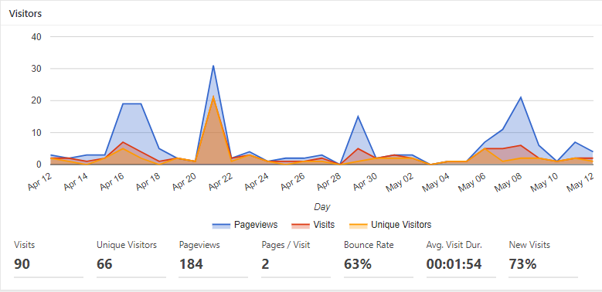

Meetings
Watershed Restoration Planning and Prioritization Meeting was held on May 8 at the Cabinet Ranger District. Primarily agency stakeholders and a few other partners reviewed and prioritized all proposed restoration projects from various watershed assessments and reports. Full day of productive discussion about the relative importance of different projects within Lower Clark Fork tributaries. Meeting notes will be out for that sometime this week.

Fly Fishing Film Tour – April 27
Successful event on April 27. Sold 106 tickets and $1778 in proceeds will go to Project ASCENT.
Story Map Project
The Lower Clark Fork Watershed Story Map and Outreach Project (funded through the Soil and Water Conservation Districts of Montana) was finalized in April. Fliers, postcards, and stickers are all still available for distribution. Check out the “story maps” on the front page of the LCFWG website (links in the slider take you to the different story maps).

Project Updates
Bull River Revegetation
- Visited all revegetation sites (save for those on federal lands, which I will be visiting on May 17), and found that about 50% are looking really good. About 50% have been very heavily browsed by beaver. It is very difficult to prevent them from entering the exclosures, especially after the fencing loosens over the winter. While it looks very disappointing, the roots are intact and there are signs that they will resprout. Additionally, the fabric is disintegrating in many areas. We will likely be focusing maintenance efforts in June on rebuilding ineffective exclosures into individual browse protectors around high value trees, and removing disintegrating materials.
Summer implementation: Plans to implement 3 different projects on the Lolo National Forest this summer continue to progress. May will be full of meetings and site visits related to the following projects as well as others:
- West Fork Fishtrap Road Realignment Project: Road designs have been received from the forest service, we are waiting for a wetland delineation to be completed (by Watershed Consulting as soon as possible), RFP for implementation is under review, and we hope to finalize designs and submit permitting applications as soon as possible.
- Graves Creek Pilot Habitat Enhancement Project: Design is finalized, and permit application (124) has been received. RFP is currently circulating, and contractor selection meeting is planned for May 23.
- Crow Creek Restoration Project – Phase 2: Design is finalized and permits are acquired, save for the 124 which I have not received yet. Contractor selection meeting is planned for May 23, and we plan to award the contract shortly after.

